Exercise 4 – Creating and Configuring a Maven Project

Name: Shubham Sangram Bej

Aim
To create and configure a Maven project using Spring Framework dependencies and Maven Compiler Plugin.

Objective
- Create a Maven project.
- Configure Spring dependencies.
- Configure Maven Compiler Plugin.
- Verify successful project execution.

Software Requirements
- Java JDK 21
- Apache Maven
- IntelliJ IDEA

Theory
Apache Maven is a project management and build automation tool. It simplifies dependency management and project builds using the pom.xml file. In this exercise, Spring Context, Spring AOP, and Spring Web MVC dependencies are added, and the Maven Compiler Plugin is configured to compile the project using Java 21.

Procedure
- Created a Maven project.
- Updated pom.xml.
- Added Spring dependencies.
- Configured the Maven Compiler Plugin.
- Created a verification class.
- Executed the application.

Output

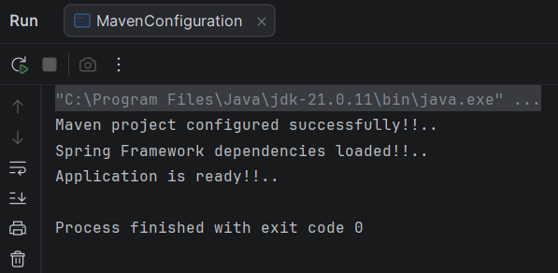

Screenshots
- Project Structure
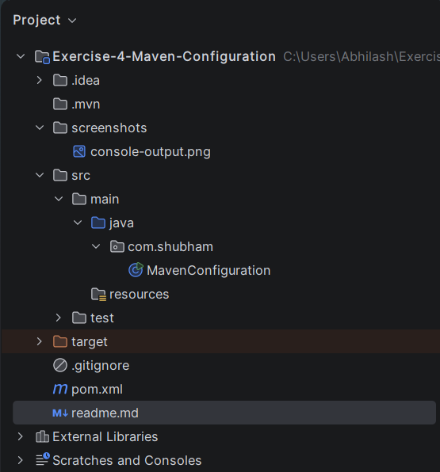

- pom.xml
<?xml version="1.0" encoding="UTF-8"?>
<project xmlns="http://maven.apache.org/POM/4.0.0"
xmlns:xsi="http://www.w3.org/2001/XMLSchema-instance"
xsi:schemaLocation="http://maven.apache.org/POM/4.0.0
https://maven.apache.org/xsd/maven-4.0.0.xsd">
<modelVersion>4.0.0</modelVersion>
<groupId>com.shubham</groupId>
<artifactId>exercise-4-maven-configuration</artifactId>
<version>1.0-SNAPSHOT</version>
<properties>
<maven.compiler.source>21</maven.compiler.source>
<maven.compiler.target>21</maven.compiler.target>
<project.build.sourceEncoding>UTF-8</project.build.sourceEncoding>
<spring.version>5.3.39</spring.version>
</properties>
<dependencies>
<dependency>
<groupId>org.springframework</groupId>
<artifactId>spring-context</artifactId>
<version>${spring.version}</version>
</dependency>
<dependency>
<groupId>org.springframework</groupId>
<artifactId>spring-aop</artifactId>
<version>${spring.version}</version>
</dependency>
<dependency>
<groupId>org.springframework</groupId>
<artifactId>spring-webmvc</artifactId>
<version>${spring.version}</version>
</dependency>
</dependencies>
<build>
<plugins>
<plugin>
<groupId>org.apache.maven.plugins</groupId>
<artifactId>maven-compiler-plugin</artifactId>
<version>3.13.0</version>
<configuration>
<source>21</source>
<target>21</target>
</configuration>
</plugin>
</plugins>
</build>
</project>

- MavenConfiguration.java
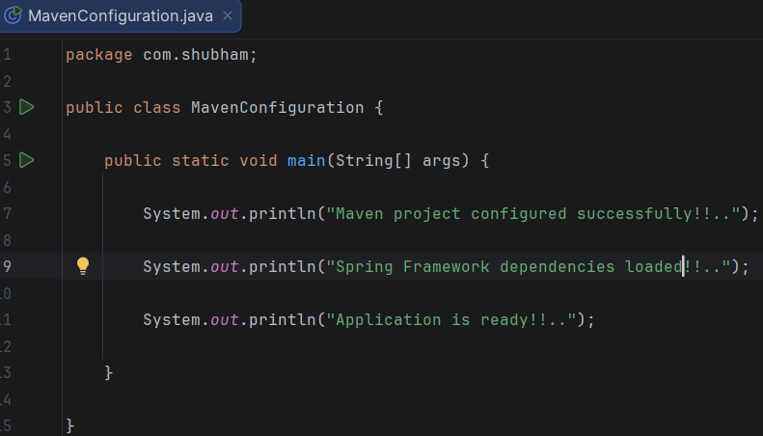

Result
The Maven project was successfully configured with Spring Framework dependencies and compiled successfully using Maven.

Conclusion
The exercise successfully demonstrated Maven project creation, dependency management, and compiler configuration.

